**Eureka-discovery-server:**

**EurekaDiscoveryServerApplication.java:**

package com.cognizant.eureka_discovery_server;

import org.springframework.boot.SpringApplication;

import org.springframework.cloud.netflix.eureka.server.EnableEurekaServer;

import org.springframework.boot.autoconfigure.SpringBootApplication;

*@SpringBootApplication*

*@EnableEurekaServer*

public class EurekaDiscoveryServerApplication {

public static void main(String[] args) {

SpringApplication.*run*(EurekaDiscoveryServerApplication.class, args);

}

}

**application.properties:**

spring.application.name=eureka-discovery-server

server.port=8761

eureka.client.register-with-eureka=false

eureka.client.fetch-registry=false

logging.level.com.netflix.eureka=OFF

logging.level.com.netflix.discovery=OFF

**pom.xml:**

<dependencies>

<dependency>

<groupId>org.springframework.cloud</groupId>

<artifactId>spring-cloud-starter-netflix-eureka-server</artifactId>

</dependency>

<dependency>

<groupId>org.springframework.boot</groupId>

<artifactId>spring-boot-starter-test</artifactId>

<scope>test</scope>

</dependency>

</dependencies>

<dependencyManagement>

<dependencies>

<dependency>

<groupId>org.springframework.cloud</groupId>

<artifactId>spring-cloud-dependencies</artifactId>

<version>${spring-cloud.version}</version>

<type>pom</type>

<scope>import</scope>

</dependency>

</dependencies>

</dependencyManagement>

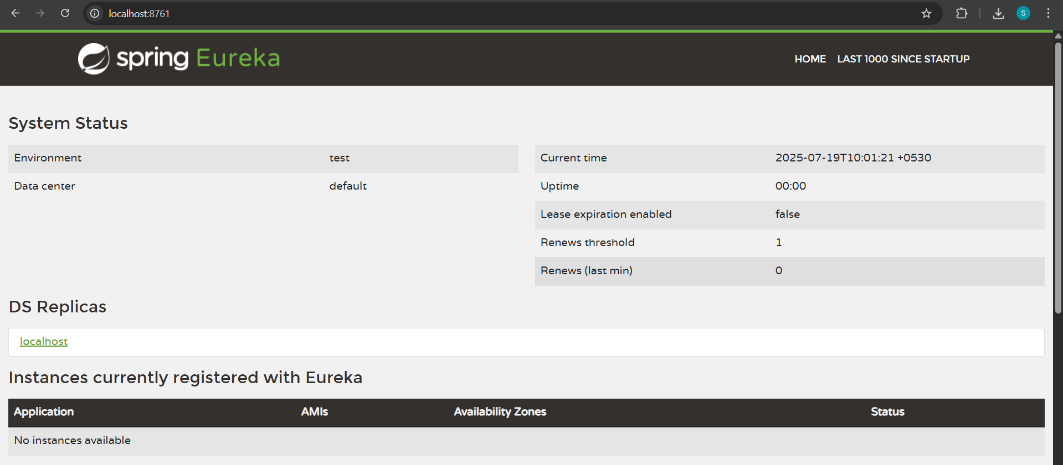

**Account-service:**

**AccountServiceApplication.java:**

package com.cognizant.account_service;

import org.springframework.boot.SpringApplication;

import org.springframework.boot.autoconfigure.SpringBootApplication;

import org.springframework.cloud.client.discovery.EnableDiscoveryClient;

*@SpringBootApplication*

*@EnableDiscoveryClient*

public class AccountServiceApplication {

public static void main(String[] args) {

SpringApplication.*run*(AccountServiceApplication.class, args);

}

}

**application.properties:**

spring.application.name=account-service

server.port=8080

eureka.client.service-url.defaultZone=http://localhost:8761/eureka

**loan-service:**

**LoanServiceApplication.java:**

package com.cognizant.loan_service;

import org.springframework.boot.SpringApplication;

import org.springframework.boot.autoconfigure.SpringBootApplication;

import org.springframework.cloud.client.discovery.EnableDiscoveryClient;

*@SpringBootApplication*

*@EnableDiscoveryClient*

public class LoanServiceApplication {

public static void main(String[] args) {

SpringApplication.*run*(LoanServiceApplication.class, args);

}

}

**application.properties:**

spring.application.name=loan-service

server.port=8081

eureka.client.service-url.defaultZone=http://localhost:8761/eureka

**Account-service and loan-service are registered with Eureka:**

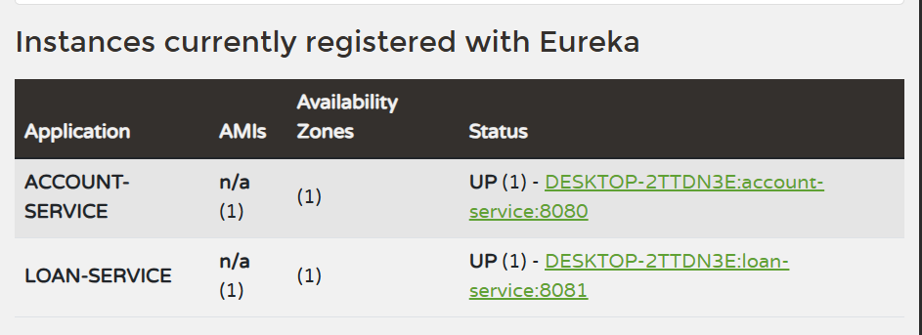

**Greet-service:**

**GreetServiceApplication.java:**

package com.cognizant.greet_service;

import org.springframework.boot.SpringApplication;

import org.springframework.boot.autoconfigure.SpringBootApplication;

@SpringBootApplication

public class GreetServiceApplication {

public static void main(String[] args) {

SpringApplication.run(GreetServiceApplication.class, args);

}

}

GreetController.java:

package com.cognizant.greet_service.controller;

import org.springframework.web.bind.annotation.GetMapping;

import org.springframework.web.bind.annotation.RestController;

*@RestController*

public class GreetController {

*@GetMapping*("/greet")

public String greet() {

return "Hello World";

}

}

**application.properties:**

spring.application.name=greet-service

server.port=8082

eureka.client.service-url.defaultZone=http://localhost:8761/eureka

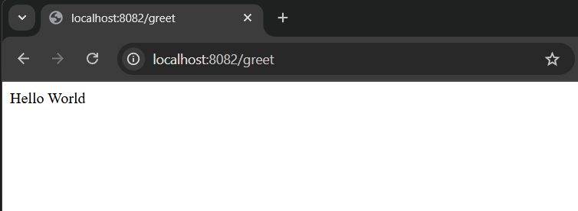

**Greet-service is registered with Eureka:**

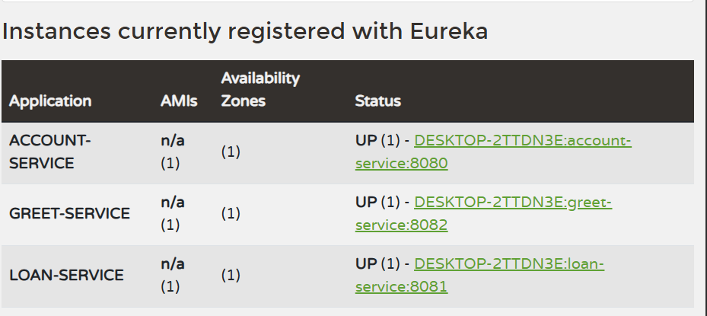

**Api-gateway:**

**ApiGatewayApplication.java:**

package com.cognizant.api_gateway;

import org.springframework.boot.SpringApplication;

import org.springframework.boot.autoconfigure.SpringBootApplication;

*@SpringBootApplication*

public class ApiGatewayApplication {

public static void main(String[] args) {

SpringApplication.*run*(ApiGatewayApplication.class, args);

}

}

**application.properties:**

server.port=9090

spring.application.name=api-gateway

eureka.client.service-url.defaultZone=http://localhost:8761/eureka

spring.cloud.gateway.server.webflux.discovery.locator.enabled=true

spring.cloud.gateway.server.webflux.discovery.locator.lower-case-service-id=true

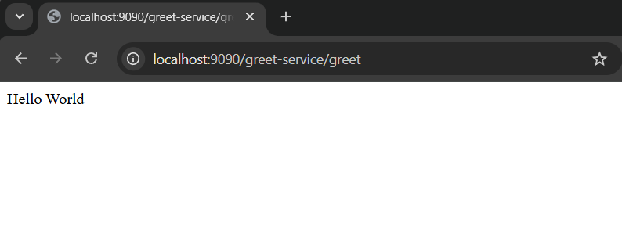

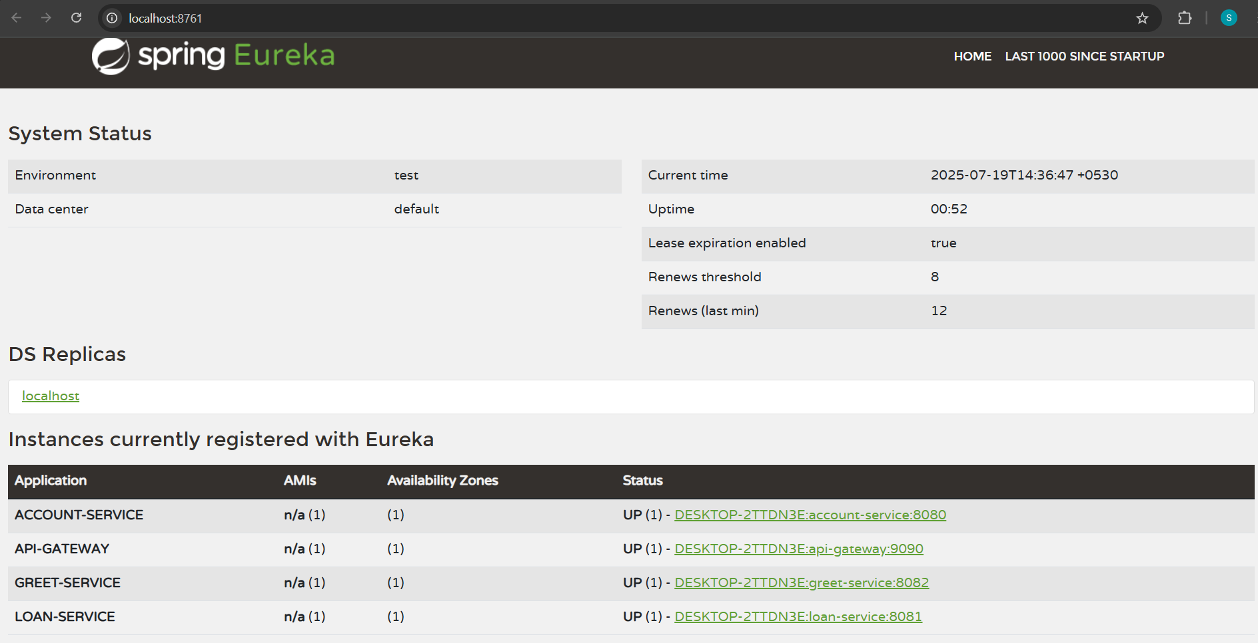

**LogFilter.java:**

package com.cognizant.api_gateway.filter;

import org.slf4j.Logger;

import org.slf4j.LoggerFactory;

import org.springframework.cloud.gateway.filter.GatewayFilterChain;

import org.springframework.cloud.gateway.filter.GlobalFilter;

import org.springframework.core.annotation.Order;

import org.springframework.stereotype.Component;

import org.springframework.web.server.ServerWebExchange;

import reactor.core.publisher.Mono;

*@Component*

*@Order*(1)

public class LogFilter implements GlobalFilter {

private static final Logger ***logger*** = LoggerFactory.*getLogger*(LogFilter.class);

*@Override*

public Mono<Void> filter(ServerWebExchange exchange, GatewayFilterChain chain) {

***logger***.info("Incoming request: {}", exchange.getRequest().getURI());

return chain.filter(exchange);

}

}



**AccountController.java:**

package com.cognizant.account_service.controller;

import org.springframework.web.bind.annotation.GetMapping;

import org.springframework.web.bind.annotation.RequestMapping;

import org.springframework.web.bind.annotation.RestController;

*@RestController*

*@RequestMapping*("/account")

public class AccountController {

*@GetMapping*("/hello")

public String sayHello() {

return "Hello from Account Service!";

}

}

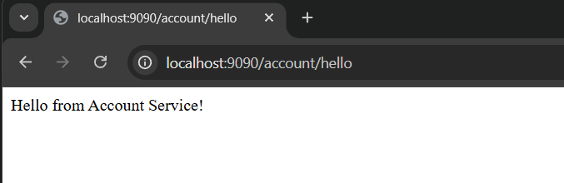

**LoanController.java:**

package com.cognizant.loan_service.controller;

import org.springframework.web.bind.annotation.GetMapping;

import org.springframework.web.bind.annotation.RequestMapping;

import org.springframework.web.bind.annotation.RestController;

*@RestController*

*@RequestMapping*("/loan")

public class LoanController {

*@GetMapping*("/hello")

public String sayHello() {

return "Hello from Loan Service!";

}

}

